Form I Social Studies
Summer Reading Assignment
Fr. Anthony fr-anthony@cistercian.org

Greetings Class of 2033,
I am your Form I Social Studies teacher!
Here is the first assignment of your Cistercian career: Choose any of the four volumes that make up Susan Wise Bauer’s The Story of the World Series and read 150 pages of it. It is your decision what volume and what 150 pages you want to cover. I, personally, would recommend one of the first two volumes – that’s the material we’ll be covering in Form I Social Studies – but you’re free to choose whatever strikes you as interesting!
After you finish reading the book, answer the questions below on a piece of notebook paper. I’d like these answers to be hand-written, in either print or cursive, and written as a “final copy” – meaning written neatly in pen without scratch outs.
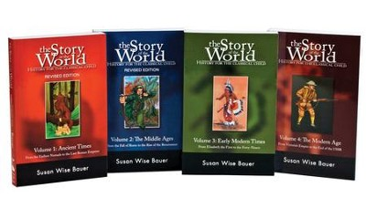
The assignment is due on the first day of History class. If you need to contact me over the summer, my email address is listed above. Have a great summer!
-Fr. Anthony

Volume #:

Pages:

Write 4-5 sentences in response to the questions below. Please cite your sources by concluding each answer with the pages that cover that response.
- What person in the book captured your imagination? Mention specific details (like something he did or maybe a direct quote) about the person that stood out to you.
- What particular event in the book were you excited to learn about? Explain what happened through using the 5 W’s: Who, What, When Where, and Why.
- A hundred pages covers many different time periods in the book. Which one would you like to live in? Mention specific things from the book that you would enjoy experiencing.
- What time period you would hate to live in? Mention specific things from the book that you would detest.
- Would you recommend this book to a friend? Why or why not? What would you tell him about it?

